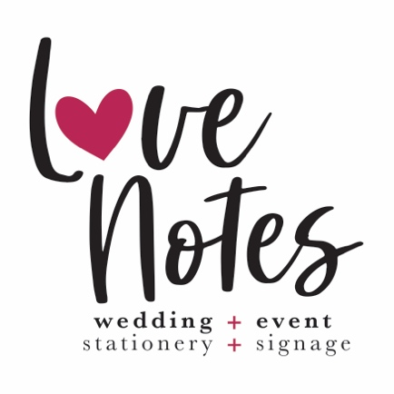
What Stationery / Signage do you require for your Wedding Day? (please supply quantities where necessary)
(Costs below include Design Time, Materials & Printing.
Please note these costs DO NOT include any Metallic, Foiling or Embossing. This will be costed separately, if needed)

Save The Date/s: (minimum 30 prints)
A5 Prints (R65 each, including A5 Envelope):
Digital (R450):

Wedding Invitation/s: (minimum 30 prints)
A5 Prints (R65 each, including A5 Envelope):
Digital (R450):

DL Menus:
Personalised with Guest Names / Food Choices (R28 each):
Generic (R20 each):

A5 Double-Sided Table Menus (in wooden stand):
Generic (R50 each):

A1 Table Plan:
180gm Paper in Frame (R850):
Forex Board (R1150):
Wood (R1850):
Perspex or Acrylic (R1850):

A1 Order of The Day:
180gm Paper in Frame (R850):
Forex Board (R1150):
Wood (R1850):
Perspex or Acrylic (R1850):

A1 Welcome Sign:
180gm Paper in Frame (R850):
Forex Board (R1150):
Wood (R1850):
Perspex or Acrylic (R1850):

90mm x 50mm Guest Name Cards:
300gm Card (R10 each):

If there is something else you require that is not listed above please specify / describe here:

