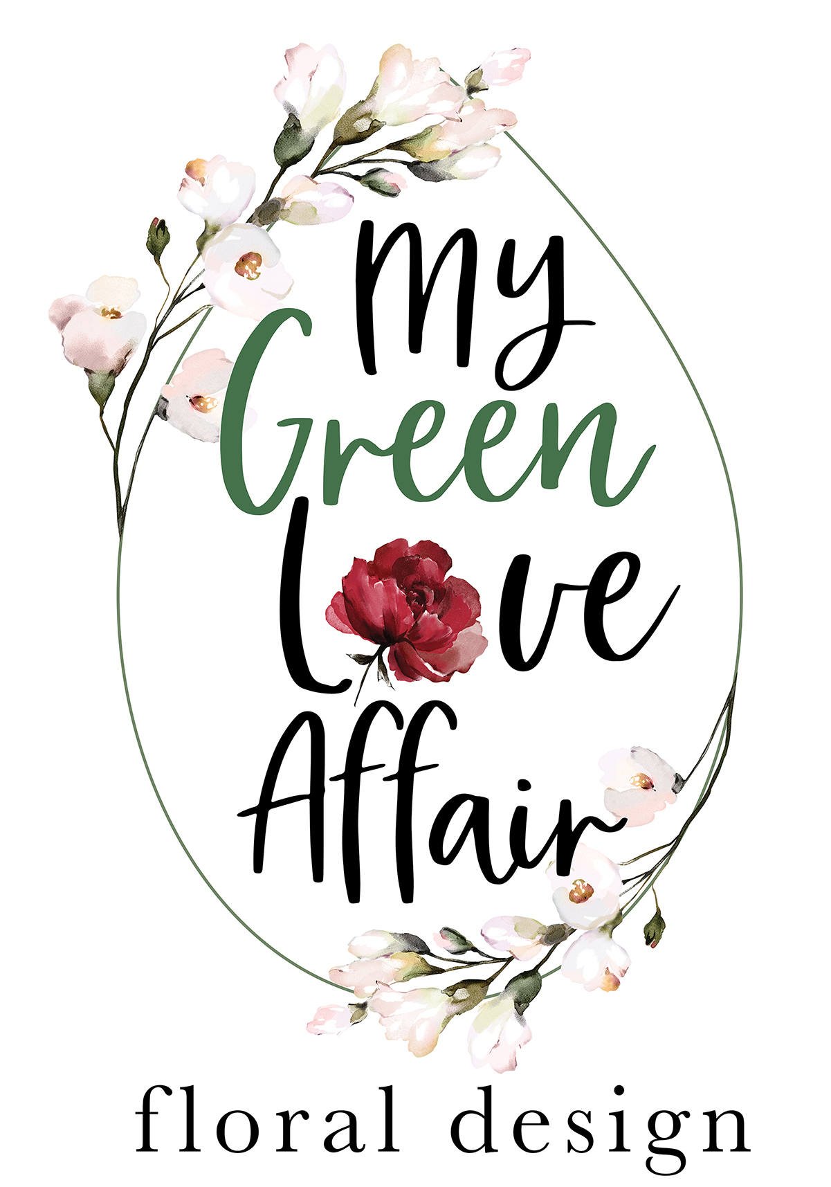
Wedding Details & Vision:

Couple's Names:

One Contact Number:

Wedding Date:

Wedding Venue:

Number of Guests:

Number of Guests Tables: (Rectangular or Round)

Is there a separate Bridal table?
If so, how many at this table:

Wedding Theme: (Tell us how you envision your day.)

Colour Scheme:

Preferred Flowers:

Disliked Flowers:

Pinterest Link:
Ceremony Décor:
Please provide reference photos where possible)

Do you require an Arch:

Decoration of Arch (Floral & Greenery Arrangement, Drapery, etc):

Aisle Décor (please specify Chair Posies, Growing Gardens, Jars on Shepherd Hooks, Wreaths or Other):

Floral Arrangements for any Plinths/Barrels (sml, med, large):

Confetti Requirements (Rose Petals, Dried Bougainvillea, Herbs & Leaves or Other):

Petal Runner for Aisle:

Ceremony Signage:

Bridal Floral: (Please provide reference photos where possible)

Bridal Bouquet:

Bridesmaid Bouquet Quantity:

Head Wreath Quantity:

Dress Corsage Quantity:

Wrist Corsage Quantity:

Boutonniere Quantity:

Loose Flowers for Hair Quantity:

Floral Clip Quantity:

Pre-Drinks Area Floral / Décor / Signage:
(Please describe what is needed here)

Reception Table Floral & Décor:
(Please provide description if no reference photo attached)

Preferred Candles: (Tea-lights, Votives, Pillars, Dinner)

Colour of Candles:

Cake/Gift/Guest Book or Signing Table Greenery & Floral Arrangements (how many):

Flowers for Cake (please specify a general amount needed):

Restroom Floral Arrangements:

Reception Signage:

Additional Floral or Décor Requirements:

How did you hear about My Green Love Affair?

MAXIMUM BUDGET:
(This helps us to determine the types of flowers as well as the abundancy of floral we can use, and also allows us to increase décor elements where necessary should it suit your theme):

Wedding Stationery:
(kindly provide quantities and a design reference if possible)

Save The Date: (printed or digital?)

Wedding Invitations: (printed or digital?)

Order of the Day: (Sign or individual prints)

Order of Service prints for the Ceremony:

Table Seating Plan: (printed on card/wood/chalkboard or perspex?)

Guest Place Names:

Menus or Personalised Guest Menus:

Favour Tags:

Any additional Customised Wedding Signage:

Other:

