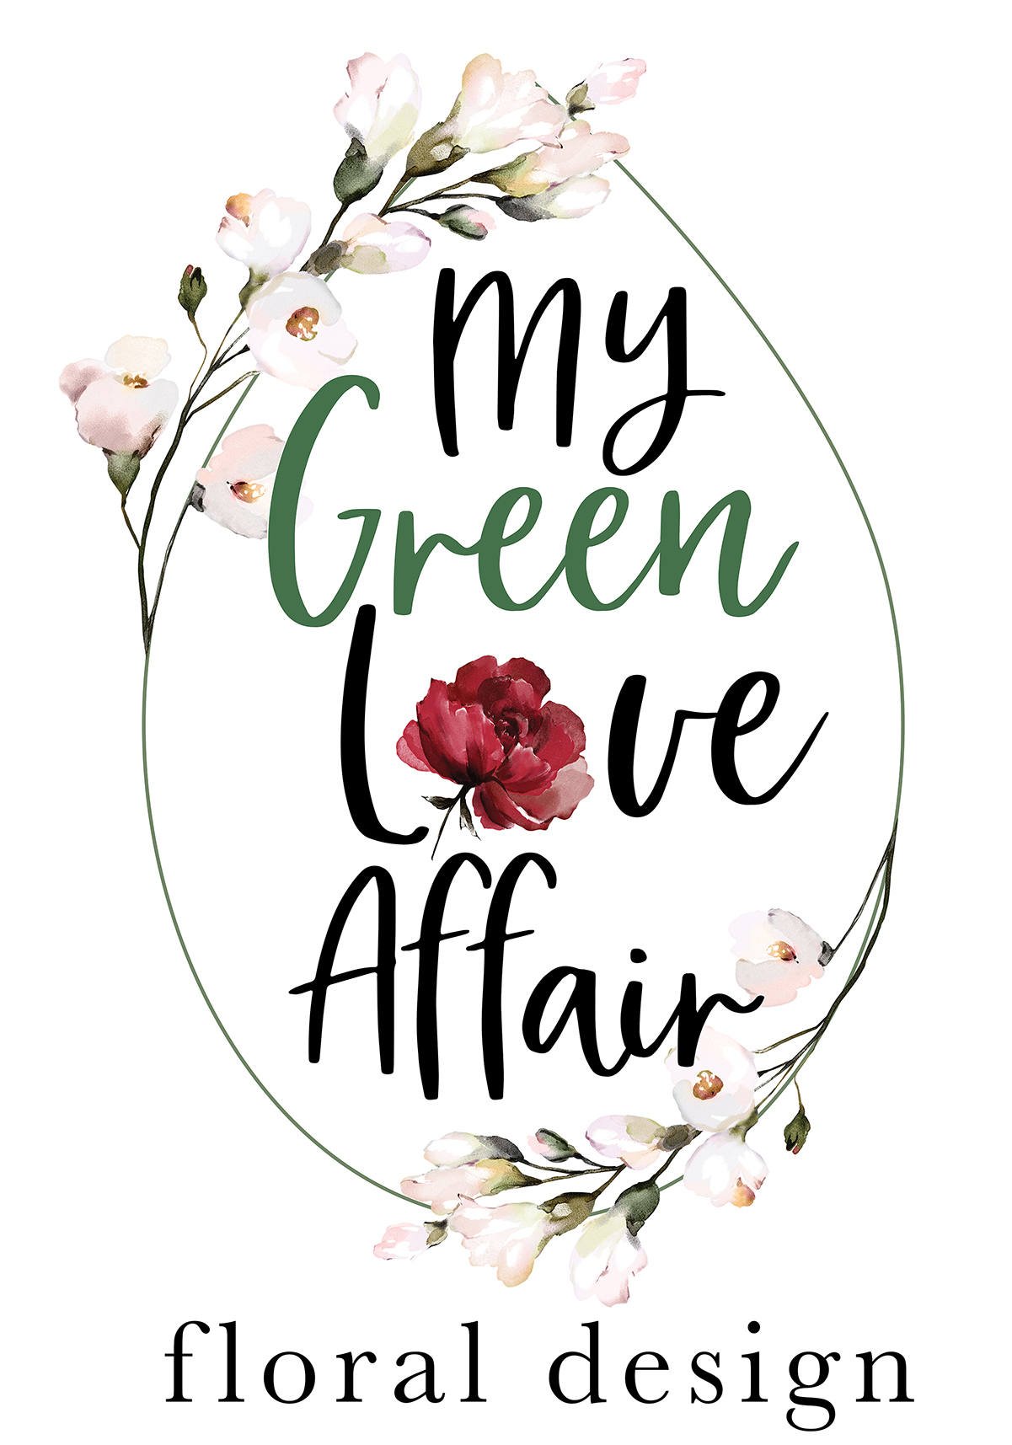
Wedding Details & Vision:

Couple's Names:

One Contact Number:

Wedding Day & Date:

Wedding Venue:
(We work exclusively in the Western Cape area and travel only +-2 hours from Cape Town for set ups)

What is your maximum Budget for your Wedding Day Florals?
(This will determine the abundancy and types of florals used)

Number of Guests:

Number of Venue Tables:
Are they Rectangular or Round?

Your Wedding Theme (please pick one)
Classic & Traditional:
Romantic & Whimsical:
Modern & Simple:
Rustic & Farmstyle:
Boho:
Eclectic:
Other (please specify or reference):

Colour Scheme:
(We use a selection of seasonal Flowers in your Colour Scheme that suit your Wedding Theme)

Are there any Flowers you really dislike?

*Please attach references here (or to your email) that reflect the general style of your Wedding Day Florals
- or your Pinterest Link:
Ceremony Florals:

Do you require one of our Arches?
Gold Metal Square:
Natural Wooden Square:
White Wrought Iron Rounded:
(Please note: Any other Arch would need to be sourced from a Hire Company and therefore an additional Sourcing, Delivery & Collection / Return fee will need to be added over and above our costs)

Florals & Greenery for Arch?
Corner:
Corner & Middle Side:
Full:
Other (please specify or reference):

Aisle Florals?
Chair Posies:
Floral & Greenery in Jars on Shepherd Hooks (soft ground only):
Growing Gardens:
Petal Runner (Full or Sides only):
Other (please specify or reference):

Do you require Confetti?
Petals Only:
Leaf, Herbs & Petal Mix:

If you are not having an Arch Ceremony, do you require other Ceremony Florals for a Church, Altar, Plinths, etc? (please specify or reference):

Bridal Party Florals:
Bridal Bouquet (please pick one style)
Structured:
Cascading:
Whimsical:
Other (please specify or reference):

Bridesmaid Bouquet Quantity:
Boutonniere Quantity:
Any other Bridal Party Florals needed? (please specify or reference):
Reception Table Florals: (Please pick one)
Your budget will determine the abundancy & quantities of your selection
Greenery & Floral Runners / Gardens / Garlands:
Floral & Greenery Arrangements in Urns / Planters:
Single Stem Floral & Greenery in Mixed Vases, Vessels & Bottles:
Other (please specify or reference):

Preferred type of Candles:
Pillar Candles:
Dinner Candles:
Votives / Tealights:
Mix:

Colour of Candles, if not White:

Additional Floral Requirements:

Pre-Drinks / Cocktail / Lounge Tables:

Signing Table Arrangement:

Gift / Guest Book Signing Table Arrangement:

Restrooms:

Flowers for Cake:

Other (please specify or reference):

How did you hear about My Green Love Affair?

Should you require any Wedding Stationery & Signage please ask for our Love Notes Form to complete. (we also supply Frames and Natural or White Easels for any Signage)

