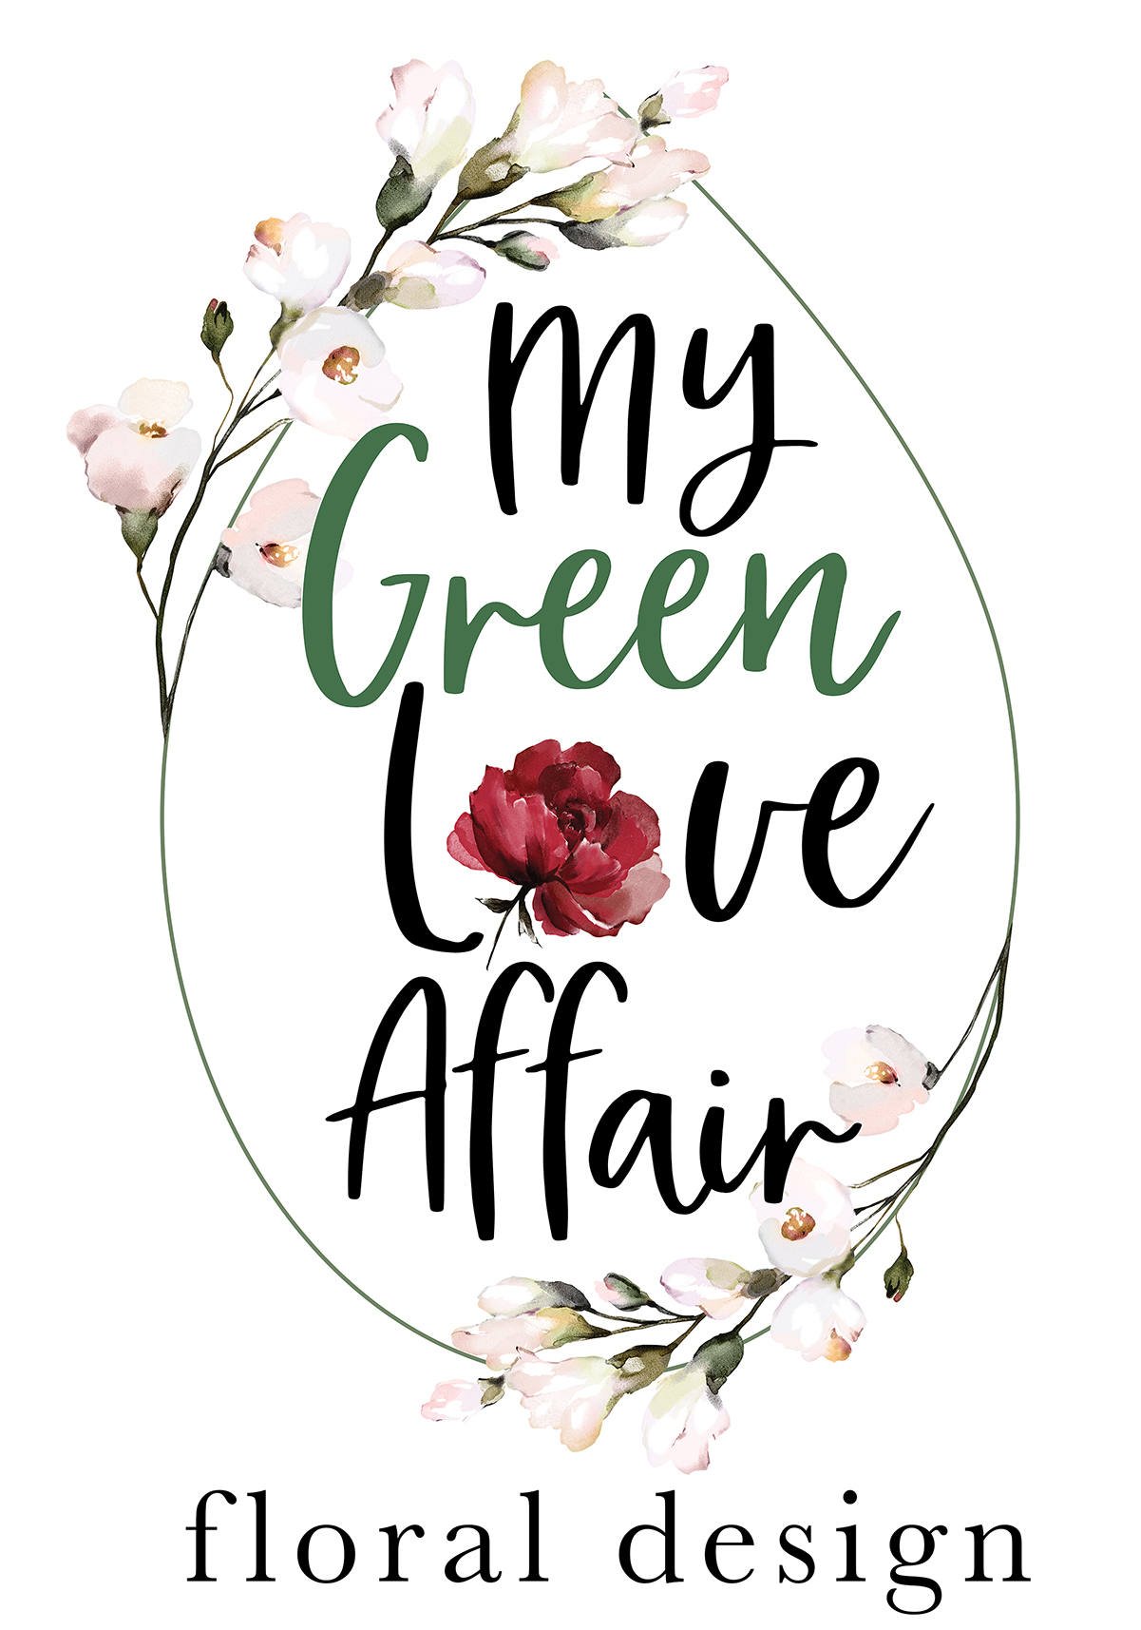
Wedding Details & Vision:

Couple's Names:

One Contact Number:

Wedding Day & Date:

Wedding Venue:

Wedding Time:

What is your maximum Budget for your Wedding Day Florals?
(This will determine the abundancy and types of Florals used)
Kindly note our minimum spend is R15 000

Number of Guests:

Number of Venue Tables:
Are they Rectangular or Round?

Is there a separate Bridal Table?
If yes, how many persons at this Table?

Your Wedding Theme (please pick one)
Classic & Traditional:
Romantic & Whimsical:
Modern & Simple:
Rustic & Farmstyle:
Boho:
Eclectic:
Other (please specify or reference):

Colour Scheme:
(We use a selection of seasonal Flowers in your Colour Scheme that suit your Wedding Theme)

Are there any Flowers you really dislike?

*Please attach references here (or to your email) that reflect the general style of your Wedding Day Florals
- or your Pinterest Link:

Ceremony Florals:

Do you require one of our Arches?
Gold Metal Square:
Natural Wooden Square:
White Wrought Iron Rounded Top:
(Please note: Any other Arch would need to be sourced from a Hire Company and therefore an additional Sourcing, Delivery & Collection / Return fee will need to be added over and above our costs)

Florals & Greenery for Arch?
Corner:
Corner & Middle Side:
Full:
Other (please specify or photo reference):

Aisle Florals?
Chair Posies:
Floral & Greenery in Jars on Shepherd Hooks (soft ground only):
Growing Gardens:
Petal Runner (Full or Sides only):
Other (please specify or photo reference):

Do you require Confetti?
Petals Only:
Leaf, Herbs & Petal Mix:

If you are not having an Arch Ceremony, do you require other Ceremony Florals for a Church, Altar, Plinths, etc? (please specify or photo reference):

Bridal Party Florals:
Bridal Bouquet (please pick one style)
Structured:
Cascading:
Whimsical:
Other (please specify or photo reference):

Bridesmaid Bouquet Quantity:
Boutonniere Quantity:
Any other Bridal Party Florals needed? (please specify or photo reference):

Reception Table Florals: (Please pick one)
Your budget will determine the abundancy & quantities of your selection
Greenery & Floral Runners / Gardens / Garlands:
Floral & Greenery Arrangements in Urns / Planters:
Single Stem Floral & Greenery in Mixed Vases, Vessels & Bottles:
Other (please specify or photo reference):

Preferred type of Candles:
Pillar Candles:
Dinner Candles:
Votives / Tealights:
Mix:

Colour of Candles, if not White:

Additional Floral Requirements:

Pre-Drinks / Cocktail / Lounge Tables:

Gift / Guest Book / Signing Table Arrangement:

Restrooms:

Flowers for Cake:

Other (please specify or reference)

How did you hear about My Green Love Affair?

Should you require any Wedding Stationery & Signage please ask for our Love Notes Form to complete. (we also supply Frames and Natural or White Easels for any Signage)

